University of Connecticut
UConn Salary Calculator Job Aid
Overview | This document will provide a step by step guide on how and when to use the new UConn Salary Calculator.
Business Process | This calculator is not required to submit a Core-CT Smart HR Template Payroll Distribution; however, it is a tool available to you to assist you in understanding the financial impact of a funding distribution as processed via the Core-CT Smart HR Templates.  This tool will also aid users in understanding the impact of the automated accrual entries that will begin posting in Academic Year 2016-2017 for all 9 and 10 month faculty.

Process Steps:
Scenario: You would like to know how much will be charged to your accounts based on the Payroll Distribution submitted on the Core-CT Smart HR Template.
Step | Action | Screenshot
1 | Navigation: Download and open the UConn Salary Calculator available at http://payroll.uconn.edu/PY/for_departments/unclassified.html
2 | Complete all fields highlighted in Blue.  The Academic Year, Semesters Worked and Employee Type fields are defaulted for Faculty that work for the entire current academic year.  Semesters Worked should only be changed for Faculty that only work in either the Fall or Spring semester. Examples: faculty hired on January 1; faculty on unpaid sabbatical in Fall or Spring semester; or faculty who leave UConn after the Fall semester. | 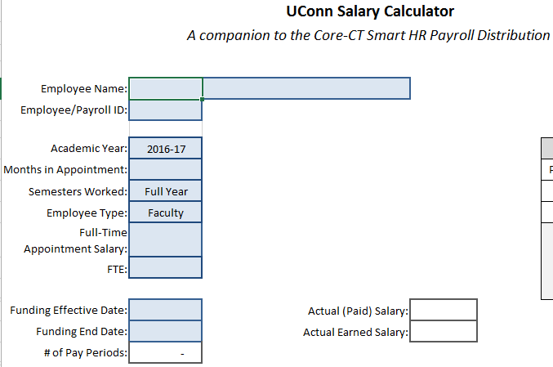
3 | Enter the Months in Appointment and then the academic year date table will populate.  - Pay/Earnings Start Date: indicates the beginning of the academic year for the semesters worked.  - Earnings End Date: indicates the end of the academic year for the semesters worked.  - Pay End Date: indicates the last day the individual will receive pay for the academic year worked. | 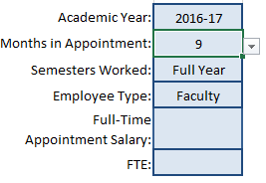
4 | Enter the FTE, Full-Time Appointment Salary, Funding Effective Date and Funding End Date.  The Funding Effective Date and Funding End Date will default to the Academic Year Earnings Start and End Dates. The Funding Dates must be within these dates. | 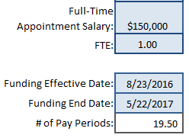
NOTES RELATED TO FUNDING DATES:
For all employees:
- If you wish to see the financial impact of a payroll distribution that crosses academic years then you will need to split the payroll distribution into two (or more) academic year periods and complete a UConn Salary Calculator for each academic year segment.
- The Funding Effective Date should align with the Job Effective Date on the Smart HR Template; however, the Smart HR Template does not need to list the Funding End Date unless there is a true end to the funding (i.e. grant end date). The UConn Salary Calculator cannot cross academic years, but the Smart HR Template Payroll Distribution can if the payroll distribution is continuing.

For 9 and 10 month faculty:
- There will be a gap period in the summer months where the UConn Salary Calculator cannot be used. All academic salary scheduled to post for summer pay periods for 9 and 10 month faculty will immediately be reversed. This tool is not designed to show the reversal.
- There must be a Smart HR Template Payroll Distribution in place for the gap period in the summer months (i.e. 5/23-8/22 for 9 month faculty). Assuming no accounts are ending, it is appropriate to have the distribution in place on 5/22 continue through 8/22, if not longer. For those with grant funding, it is no longer required to switch the funding distribution to non-grant sources in the summer months. Grant accounts can remain on the Smart HR Template Payroll Distribution throughout the summer.
5 | Once the Funding Dates have been entered, you will see the following:  - Actual Paid Salary: the total amount that the individual will receive in their pay check between the listed Funding Dates.  - Actual Earned Salary: the total amount owed to the individual for the work that they have done between the listed Funding Dates.  This is the total salary charges related to the listed funding period that will be posted to all KFS accounts. | 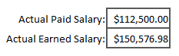
6 | Enter the KFS Account numbers and pick a method to distribute salary – either the:  - % Effort or  - Total Amount of Salary to be charged (including accruals)  You must choose one option to apply to all accounts.  The first account line will determine the method used.  If you have already submitted the Payroll Distribution on the Core-CT Smart HR Template, you can enter the Distribution Percentage for each account under the % Effort column. | 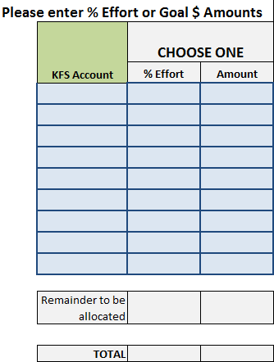
7 | The UConn Salary Calculator should list all accounts on the Payroll Distribution.  - If using the Allocate by Effort method, the % Effort column should total 100%.  - If using the Allocate by Amount method, the Amount column should equal the Actual Earned Salary amount listed above.  The Remainder to be allocated line will display (in Red) any unallocated effort or dollars that need to be distributed to a KFS account. | 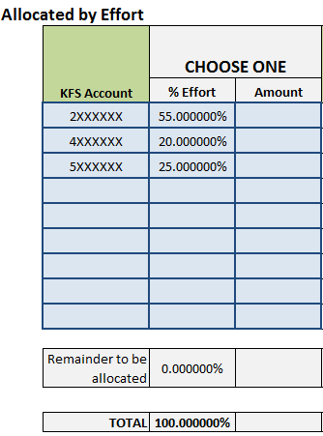
8 | 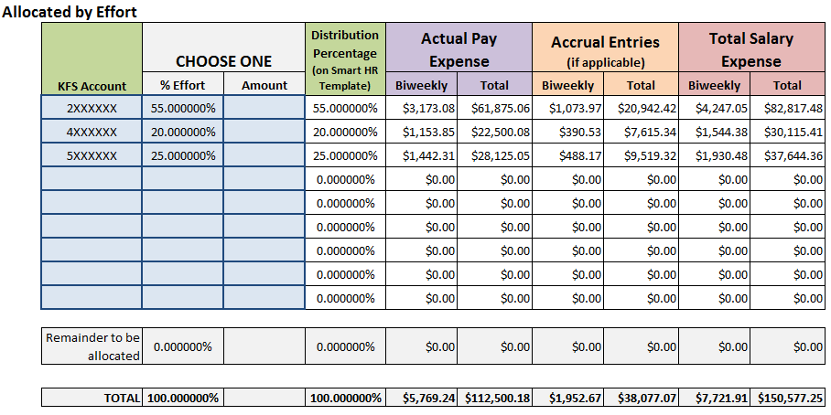
DEFINITIONS:
- Distribution Percentage: this is the percentage of the total salary that should be allocated to each account. This percentage should match the Smart HR Template Payroll Distribution. If using the Allocate by Amount method to determine the percentages prior to completing the Smart HR Template, this is the percentage you should use to populate the Smart HR Template Payroll Distribution.

The following expenses are listed as both the bi-weekly amount and the full funding period amount:

- Actual Pay Expense: this is the amount that the individual receives in their pay check by KFS account in the listed funding period.

- Accrual Entries: applicable for 9 and 10 month Faculty ONLY, this is the amount that the KFS account will be charged – in addition to the pay check – related to the difference between the amount the individual earns for the funding period and the amount they are paid in the funding period. The accrual entries effectively shift the academic year salary paid in the summer to the academic year when the work is performed/salary is earned.

- Total Salary Expense: this is the total amount that will post to the KFS account for the individual in the listed funding period. This is the sum of the Actual Pay Expense and the Accrual Entries (if applicable).
 | NOTE: The amounts on the UConn Salary Calculator do not include fringe. As KFS will reflect separate transactions for the Actual Pay Expense and the Accrual Entries in each pay period, fringe will be calculated based on each of those expenses. This will result in four transaction lines for each 9 and 10 month faculty member per account and per pay period: (1) actual paid salary, (2) accrued salary, (3) fringe for actual paid salary and (4) fringe for accrued salary.
9 | Finally, if desired, you may enter Comments for your own records.

